Name: Pranali Sonawane
Subject: CCNA
Lab – HSRP(Hot standby Router Protocol):
First, we have taken one switch, two PCs, and two routers. The PCs are connected to the switch using straight-through cables. The routers are also connected to the switch using straight-through cables.

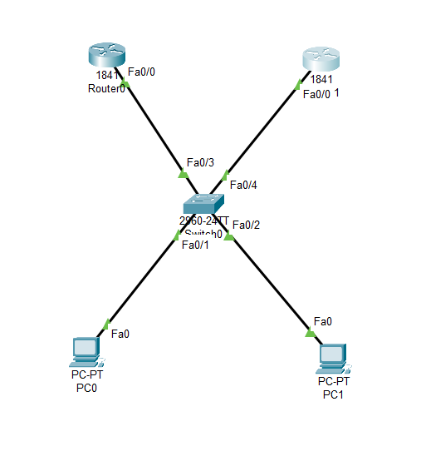
Open Switch 0 – CLI prompt then type following commands
Switch>enable
Switch#config terminal
For VLAN 10 :
Switch (config)#vlan 10
Switch (config-vlan)# name CCNA
Switch (config-vlan)#exit

Switch (config)#interface fastEthernet 0/1
Switch (config-if)#switchport mode access
Switch (config-if)#switchport access vlan 10
Switch (config-if)#exit

For VLAN 20 :
Switch (config)#vlan 20
Switch (config-vlan)#name MCSA
Switch (config-vlan)#exit

Switch (config)#interface fastEthernet 0/2
Switch (config-if)#switchport mode access
Switch (config-if)#switchport access vlan 20
Switch(config-if)#exit

Switch (config)#interface fastEthernet 0/3
Switch (config-if)#switchport mode access
Switch (config-if)#switchport access vlan 10
Switch(config-if)#exit

Switch (config)#interface fastEthernet 0/4
Switch (config-if)#switchport mode access
Switch (config-if)#switchport access vlan 20
Switch(config-if)#exit
Open Router 0 – CLI prompt then type following commands
Router>enable
Router#configure terminal
Router(config)# interface fastEthernet 0/0
Router(config-if)# ip address 10.0.0.2 255.0.0.0
Router(config-if)#no shutdown
Router(config-if)#standby 1 ip 10.0.0.1
Router(config-if)#standby 1 priority 110
Router(config-if)#standby 1 pre-empt
Router#show standby brief
Router(config-if)#ip dhcp pool DHCP
Router(dhcp-config)#network 10.0.0.0 255.0.0.0
Router(dhcp-config)#default-router 10.0.0.1
Router(dhcp-config)#ip dhcp excluded-address 10.0.0.1 10.0.0.9

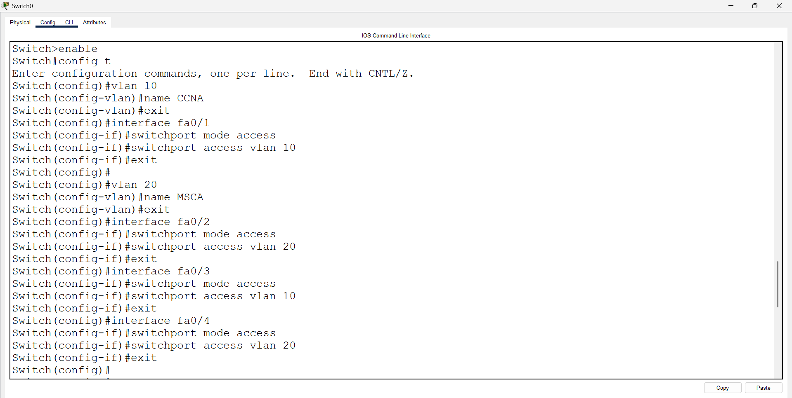

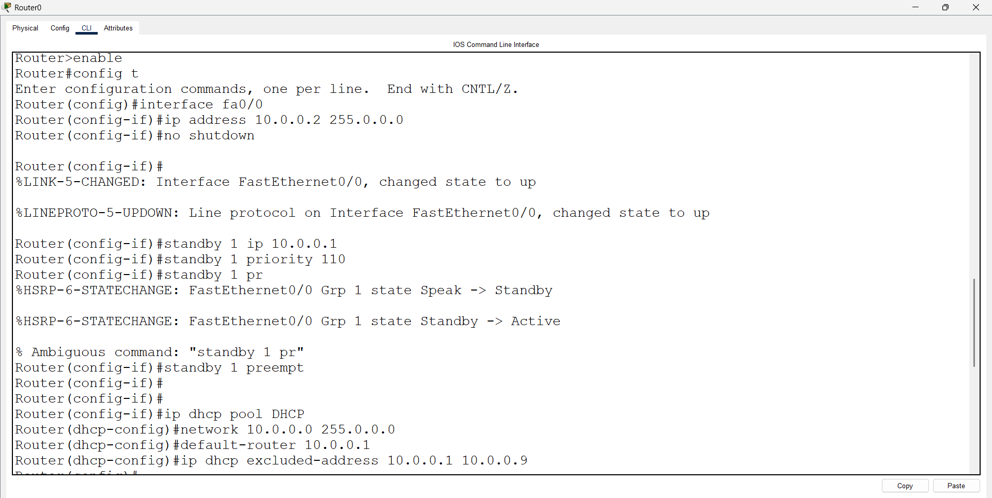
Open Router 1 – CLI prompt then type following commands
Router>enable
Router#configure terminal
Router(config)# interface fastEthernet 0/0
Router(config-if)# ip address 20.0.0.2 255.0.0.0
Router(config-if)#no shutdown
Router(config-if)#standby 2 ip 20.0.0.1
Router(config-if)#standby 2 priority 110
Router(config-if)#standby 2 pre-empt
Router#show standby brief
Router(config-if)#ip dhcp pool DHCP
Router(dhcp-config)#network 20.0.0.0 255.0.0.0
Router(dhcp-config)#default-router 20.0.0.1
Router(dhcp-config)#ip dhcp excluded-address 20.0.0.1 20.0.0.9

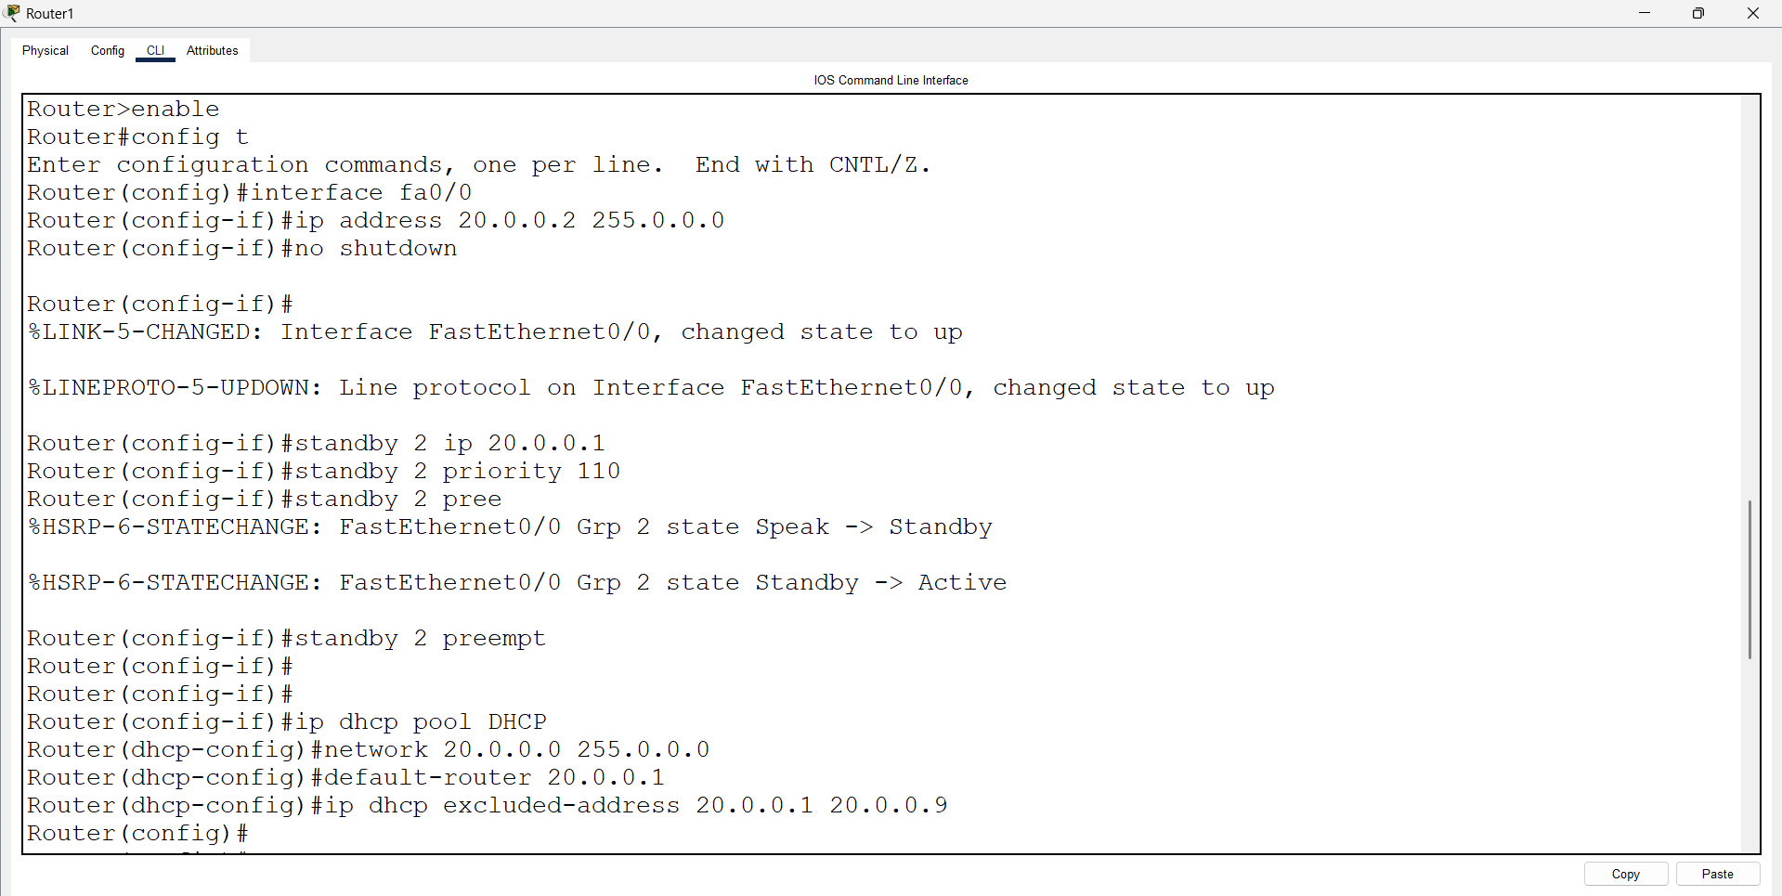

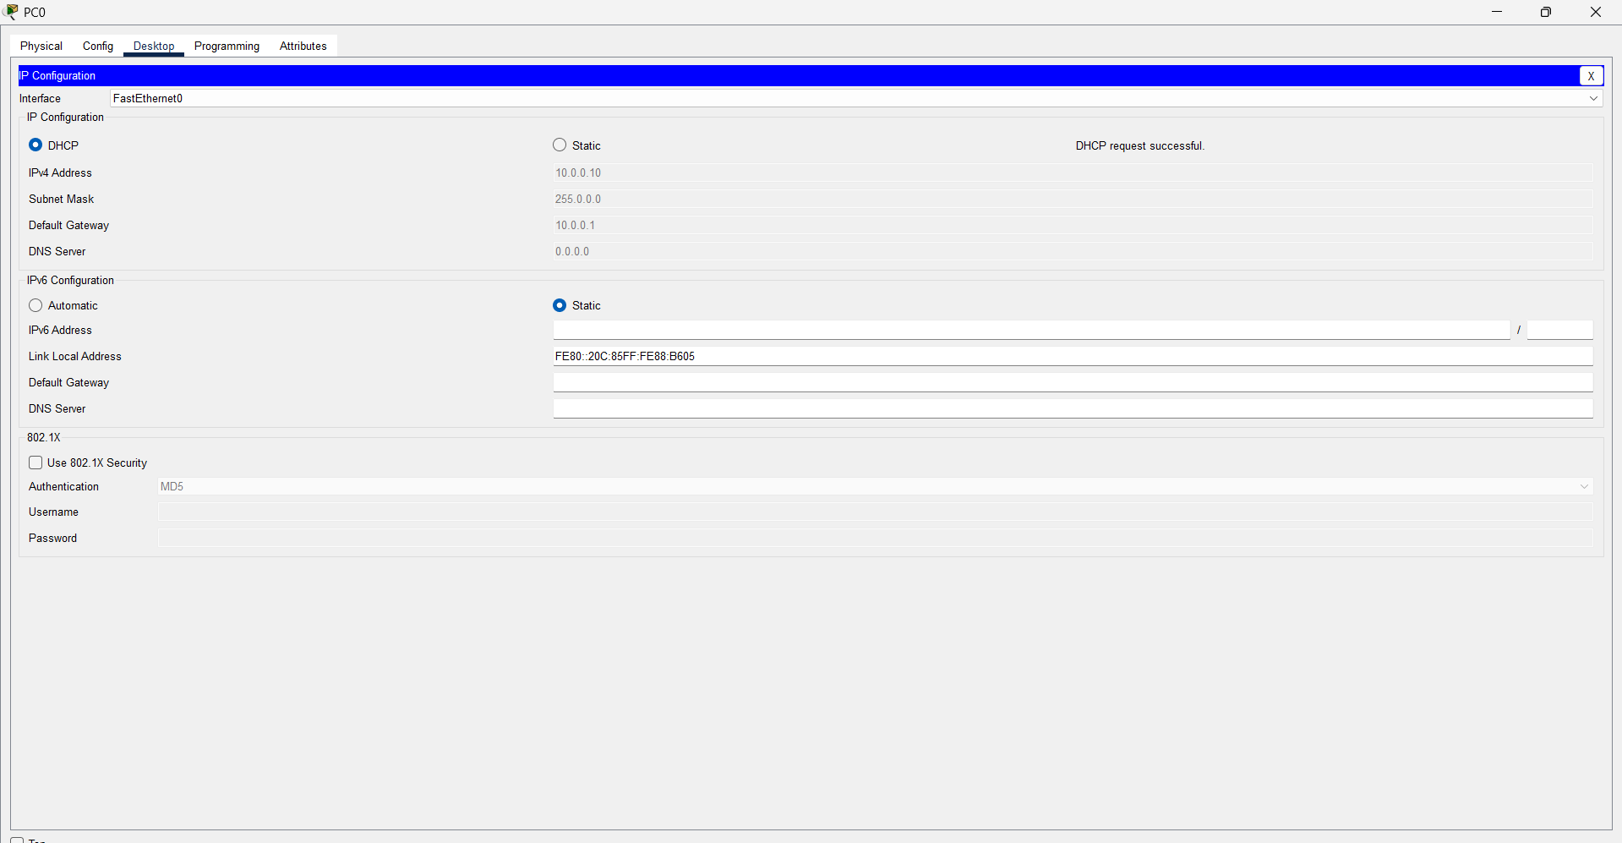

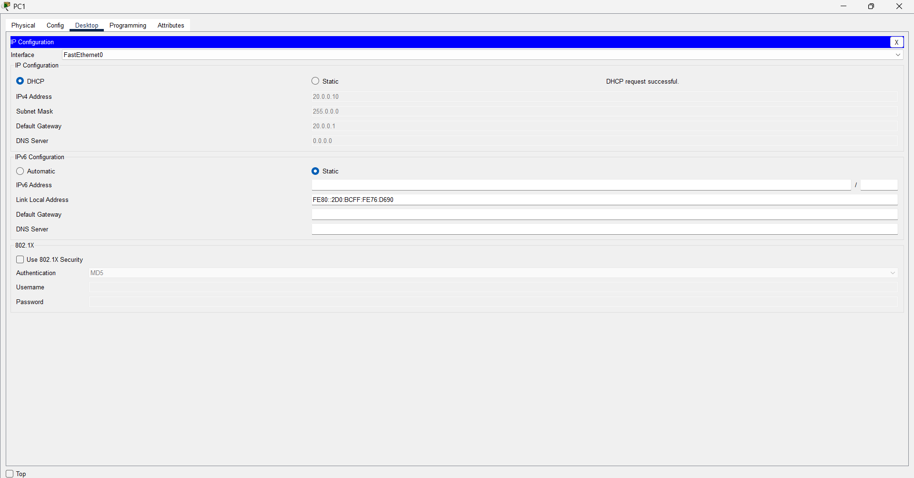
Open pc 0 – cmd prompt – type command
>ping 10.0.0.10

